Q1 (I)

**Using Comments in Python**

*Comments* are pieces of code that are not executed by the compiler. Why are we

starting our programming chapter with commands that would not be run? Because

comments are a vital part of any programming project.

Comments are lines of code that the programmer puts there for others to

understand the code better. For example, if you want to explain what a particular

piece of code does, you may begin with a comment that explains what it does and

what the result will be.

How do we write comments in Python? Comments are lines of code that start

with a pound sign, **#**. The following is an example of a comment.

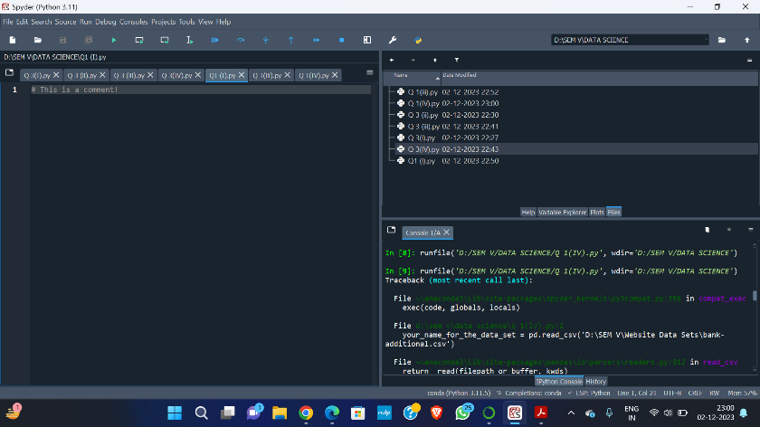

# This is a comment!

Notice that the typeface for any code, even comments, will be given in boldface

in this textbook. This applies to both Python and R code.